Equality and Diversity Good Practice Fund
Northern College – Identities Project
June 2015 – Final Report
“I’m a different teacher now. I resist the labels; the pigeon-holing; the merging of ‘equality and diversity’ into something meaningless, about ticking a box. As Audre Lorde said ‘There is no such thing as a single-issue struggle, because we do not live single-issue lives.’”
Identities Programme participant

Project Summary
Our overarching project aim was to ‘change the way that educators talk about diversity, intersectionality and identity’. Through this, we wanted individual participants and their students to be able to express their identities safely without prejudice.
The project used Thinking Environment processes to challenge untrue limiting assumptions made about aspects of identity and about intersectionality and privilege; difficult concepts to articulate and ones which are generally unacknowledged in the sector.
All chosen project participants (‘Identity Champions’) teach students who are drawn from the most vulnerable groups in society and operate in organisations (or networks of vol/com organisations) where they are able to influence how identity is recognised, celebrated and promoted. Our aim was that ultimately all users of those services will benefit from being recognised as complex individuals, rather than diversity ‘labels.’
In conjunction with face to face coaching and workshops, a social media campaign took place, attempting to change the way ‘deficit’ language is used across the sector to describe equality and diversity.
The process:
In December 2015 the project team was established (project manager, researcher, ICT support, coach) and twenty educators from a variety of sectors were selected via an application process to take part in the project.
On 27 February a project initiation day was held, which introduced the themes of the project and the participation requirements (to take part in personal Thinking Environment coaching and create a media piece to share their learning).
The coaching sessions took place between March and June. Twelve participants took part, exploring their own identities and approaches to embedding equality and diversity, followed by action planning and goal setting.
The project themes and ideas were promoted via social media in the following ways:
- These Are My Words – Twitter account (@TDIdentities established). Activity in March alone showed interaction with over 200 individuals/organisations outside of the project (see Appendix 1)
- A project website, https://tdidentities.wordpress.com/ was created to store reflections and act as an outward-facing area to promote the work of the project
- A Padlet site to store reading materials, resources, and the pieces created by project participants was set up and continues to grow as further items are added http://padlet.com/teachnorthern/1o5tjeqff8qg
A follow-up workshop took place on 8th May 2015 where participants:
- Shared their learning so far and explored the shift in thinking about their own identities
- Discussed issues arising from the project in critical thinking groups
- Learnt how to use Thinking Environment techniques to engage students in identities work in their own practice contexts.
The words and phrases used to talk about equality, diversity and inclusion were captured and the changes tracked at both workshops by an observer:

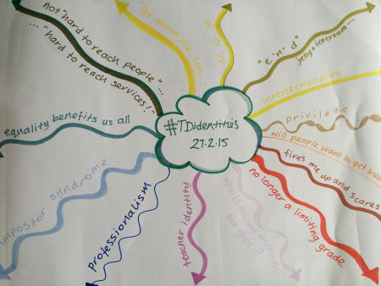
Capturing language used on workshop day 1

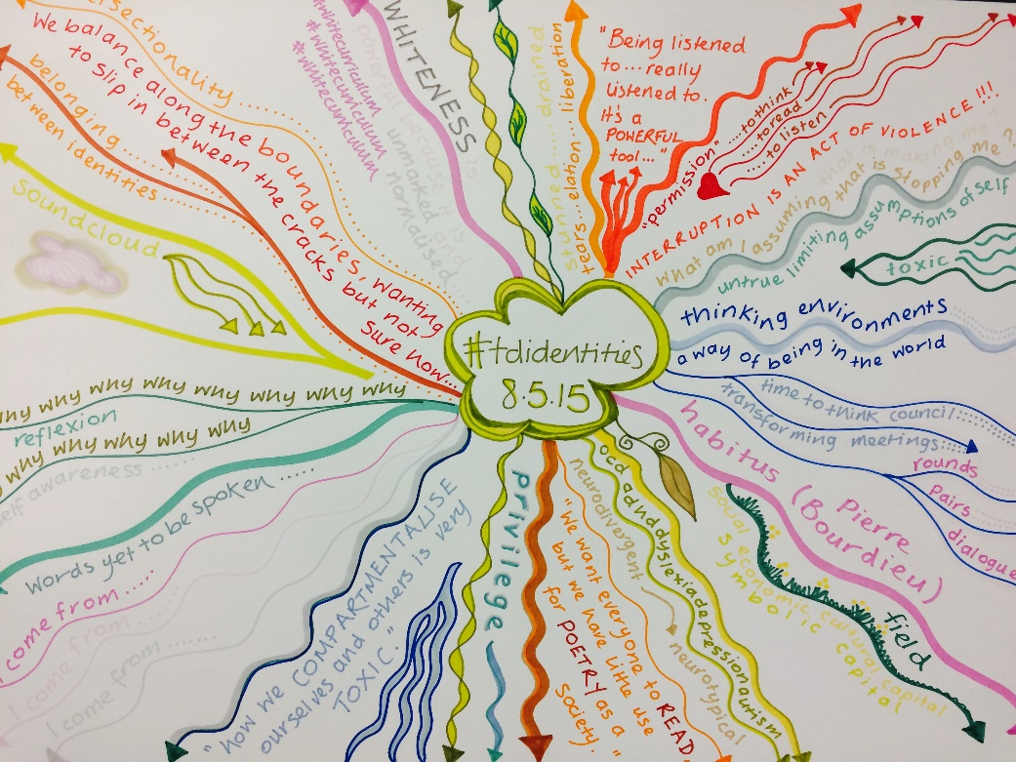
Capturing language used on workshop day 2
By the end of June 2015, project participants had created over 50 media and reflective pieces (blogs, poems, artwork, Wordles, text images, games, videos etc. Please see the Padlet for the full collection).
Short/long term impact of the project
“Upon reflection I have found attending the Identities programme profoundly moving. I feel that the gates of my consciousness have started to open. This whole humanistic approach is acutely liberating; how we compartmentalise ourselves and others is very toxic. I feel that through learning the principles of the thinking environment, these techniques will not only enrich my personal relationships but also improve my working and social relationships. I am very grateful.”
The key successes have been around the learning, impact and reach of the project. Key learning points are:

- Acknowledgement from participants that the ability to take part in difficult conversations around diversity, intersectionality, and privilege in teaching practice relies on a high degree of self-awareness.
“Some of it I found quite challenging but challenging in a really, really nice way and a positive way because it made me think about myself: who I
am; what I do; how other people perceive me and sometimes how I perceive myself…”
- Without knowledge of oneself and one’s own identity (and having the space and time to explore this), it is very difficult to be confident in facilitating effective classroom discussions. The coaching and reflective elements of the project have therefore been key here.

One of the key roles of the coach has been to help shape incisive questions to challenge prevailing thinking about the ‘silos’ of protected characteristics and break through the self-limiting assumptions founded in personal experience.

Reflections from the coachees can be found in the accompanying evaluation summary at Appendix 3, and on the project WordPress site:

https://tdidentities.wordpress.com/

- Using Thinking Environment approaches with students naturally embeds diversity, through the very principles the applications are based on. For example, the levelling and inclusive nature of thinking rounds give each individual a voice; encouraging attention and diversity of opinion fosters respect. As a result, the programme participants are keen to further these facilitation skills as a means of embedding diversity in their own practice.
- Where individuals lack confidence in embedding equality and diversity, this is often due to a lack of personal knowledge. For example, some participants expressed a reluctance to engage with or challenge students when issues of race arose in the classroom. Exploration of personal identity uncovered knowledge gaps and through coaching, the following goals were identified:
  - To explore the concept of ‘white work’ via tools such as #whitecurriculum or join a MOOC on the subject of critical race theory
  - To explore gender work, such as feminist theory and politics of gender
  - To read work around neurodiversity and change the ‘deficit’ model of language around labels such as dyslexia, ADHD, and autism
  - To examine the concept of white privilege, using the writing of Peggy Macintosh and Twitter contacts such as @writersofcolour.
A number of these supporting resources were gathered in the project Padlet to provide supporting information and to stimulate thinking.
- Encouraging creative approaches is pivotal to explorations of identity. The poem ‘I Come From’ was used as a stimulus; participants then chose to explore their own identities using a variety of media; poetry being just one of these. By allowing students (and ourselves) to self-select their medium, and encouraging diverse approaches, deeper and more meaningful connections can be made. Many participants were truly proud of their creative work and have been inspired to continue writing, drawing etc:

“My idea for my ‘product’ was to get my fellow students to photograph themselves and look at their identity and I still might do that but time wise that’s not been really possible so in the end I wrote a poem which I couldn’t really do before for a long time and then it just happened. It was quite interesting and it was a poem, it wasn’t just my rambling thoughts; I was really quite surprised. So the opening up of that and the possibility of that surprised me. I knew how I felt about certain things but I hadn’t actually put it down on paper and just writing the poem was quite an interesting experience. It happened in fifteen minutes; it was just… I was in the right place to do it.”

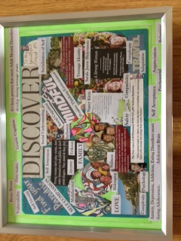
Montage created by an Identities Project participant

Summary:
As a result of this project:
- Thinking Environment approaches to embedding equality and diversity (thinking rounds, thinking pairs, the Ten Components) are now used at 8 institutions
- A shift in language has been seen, as participants moved from talking about equality and diversity to using terminology such as identity, intersectionality, privilege, white work etc.
- A network of ‘identity champions’ exists and continues to discuss equality and diversity issues, share resources and instigate new teaching practices.
Project participants reported a growth in personal confidence regarding the embedding and integration of equality and diversity in their practice (see the accompanying Evaluation Summary at Appendix 3 for full details).
Embedding and sustaining good practice
A clear message from the project evaluation was the call for participants to reconvene in the autumn term, to continue sharing good practice and to consider impact. Discussion will be undertaken with ECU regarding the possibility of carrying forward a small amount of funding to facilitate this event.
Participants will be able to continue conversations, share good practice and gain on-going support through the Yammer space originally created as a communications tool for the project. Useful resources are still being shared here on
a regular basis, and the Padlet continues to be populated with reading materials and articles of interest around the identities theme.
Outputs and resources
The project background and impact was initially shared at the Northern College ‘Teach Different’ Education Conference on 4th July 2015. A number of internal and external contacts from across adult education have been provided with the project materials and resources in order to embed the identities work in their own practice.
The Identities approach to embedding equality and diversity has also been rolled out at Barnsley College, via a number of workshops during their Teachers’ Fair CPD week.
Two project participants will also be running a workshop at the UKFEchat national conference for FE educators in London on 24th October 2015.
In addition to the Padlet with its wealth of identity resources, the following tools have been created:
- ‘Teaching in a Thinking Environment’ video scribes https://www.youtube.com/watch?v=IYWDCjYmQ7w
- An Identities example lesson plan
- A draft ‘cultural competence’ framework which examines new ways to integrate and promote diversity.
These tools will continue to be developed and shared over summer 2015.
A version of the Identities programme can also be offered to interested organisations who would like to take this work forward in their own educational context.

Key messages to those undertaking similar projects:
Given the nature of the personal explorations around identity, it is essential to use trained coaches who are able to distinguish between guided and therapeutic approaches to coaching. Our recommendation is for use of Thinking Environment methods which uncover limiting assumptions, coupled with the more traditional GROW model which provides clear direction and goal-setting.
Creation of safe spaces through the co-construction of group agreements and on-line discussion forums is essential (we used Yammer for this; it also works well as a project management tool).

Kay Sidebottom
Northern College
June 2015

Appendix 1 – March Twitter Summary

MARCH 2015 SUMMARY

Tweets
43

Tweet impressions
6,795

Profile visits
214

Mentions
52

New followers
15

Appendix 2 – Participating Institutions
Barnsley College
Doncaster YMCA
Halifax Women Centre
Headway Rotherham
Northern College
Rotherham District Council
Sheffield Adult and Community Learning
Sheffield Hallam University
Workers’ Educational Association (WEA)
University of Huddersfield

Appendix 3 – Evaluation Summary
Jill Wilkens (Researcher)

The following is a summary of key findings arising from interviews with project participants undertaken in June 2015 by Jill Wilkens (project researcher).

Motivation to be part of the programme
Northern College’s reputation is important in attracting participants.
Northern College is seen as offering an ‘alternative’ way of doing things.
Direct recommendation, e.g. via Kay working at Barnsley College, Lesley working at the Women’s Centre, is very significant.

Feelings about the two face-to-face workshop days
The workshop days were seen as interesting and useful.
Having the opportunity to share ideas and resources was highly valued.
Having the opportunity to talk and be really listened to (Thinking Environment) was highly valued.
People seemed to be particularly drawn to the discussion of ‘imposter syndrome’ which resonated with several participants.
A couple of participants found the use of the Thinking Round challenging at first because they were worrying about what they were going to say. These fears disappeared by the second session.
One participant felt overwhelmed by the ‘grandness of the vocabulary’ on the first day. This participant described the second day as ‘joyous’.

Feelings about the use of the Thinking Environment in the workshop days
All participants (and staff) found the use of the Thinking Environment absolutely essential.
The Thinking Environment was seen as providing a framework.

Several participants have subsequently tried out elements of the Thinking Environment in their own practice with positive outcomes.
Several participants have used Thinking Environment principles in their personal life with positive outcomes.
The Thinking Environment was viewed as a second distinct and key element of the identities work.
Once people get used to working in a Thinking Environment they find it challenging to work in any other way.
Feelings about the coaching experience
The coaching provided a safe environment.
Some participants were surprised to find themselves sharing personal and emotional issues.
The participants who shared personal and emotional issues really valued the opportunity and felt it had cleared the way for them to be able to think more clearly about identity.
People really valued being listened to.
One participant described the coaching as a ‘truly liberating experience’.
Some participants would have liked more coaching sessions.
Participants and the coach liked the use of different coaching models.

Feelings about the Yammer community and other online spaces
Yammer was seen by participants and staff as an important component of the project.
Some participants find it useful as an information gateway, alerting them to events and reminding them of things to do.
Being able to post things on Yammer and get appreciation from others boosted the confidence of some participants.
One participant said ‘Yammer made me feel part of a community’.
Yammer was seen as more challenging by participants with dyslexia and those people who are less confident with their written expression. One person expressed a fear of: ‘being judged by my written word, my spelling, grammar, vocabulary. Not being witty enough or thought provoking or eloquent.’
The facilitators of the project viewed the use of Yammer as essential as a way of making connections, sharing resources and maintaining an online community.

Media pieces
Participants have created a variety of media pieces.
The most popular ‘product’ was poetry, generally in the form of an ‘I come from’ poem.
Other pieces include a typography, a soundcloud and animated videos.

How did thinking about identities change across the life course of the project?
People’s thinking about identities has been profoundly influenced by the programme.
There was a general consensus that an understanding of one’s own identity is essential for teachers aiming to promote equality and diversity.
All participants felt that they were now more open and less judgemental.
All participants felt that they had a better understanding of their own identity and that of others.
Staff were also impacted by the project in a highly positive way.
Some people resisted an identity label for themselves.

What were the main outcomes of participation in the project?
For one participant the coaching was a really useful aspect of the project. They also benefitted from a greater understanding of the ‘imposter syndrome’

One participant found that they were better at listening to and accepting others.
The Thinking Environment was seen as really valuable as it offered the opportunity to reflect.
The impact of the project was both personal and professional.

What was the impact of the project on others?
The project has impacted on others because participants have taken aspects of the Thinking Environment and identities work into their professional practice with students and colleagues.
Some participants referenced the positive impact on their families.

What motivated participants to stay on the programme?
People were motivated to stay on the programme because of the approach and encouragement of the staff.
The Yammer group was also motivational.

Did participants set any goals at the start of the programme?
Participants tended not to set goals at the start of the programme. They viewed it as more organic.

What was the most useful aspect of the whole experience?
For two people, the coaching was the most useful part of the whole experience.
Three participants viewed the Thinking Environment as the most useful aspect of the project.
Another participant felt that they had developed a greater ability to question things (including themself).
What was the least useful aspect of the whole experience?
Most participants could not answer this question.
One participant talked about their lack of confidence as a ‘non-academic’.
One person said ‘Yammer but only because I’m not into blogging/tweeting etc.’
One person said ‘I can’t honestly come up with anything; I think I'd be clutching at straws.’
Did anything surprise you?
Discovery/reigniting creativity.
Three people referenced the fact that they had written a poem.
One person was profoundly impacted by the discussion on gender being not who you are but what you do.
One person was really surprised by their own attitude, which turned from skepticism to enthusiasm and engagement within the morning of the first workshop.
One participant was surprised by their increased confidence between the two workshop days. The same participant also referenced the ease with which they embraced the Thinking Environment
Next steps
Participants’ ‘next steps’ were mostly around trying to embed aspects of the identities work and Thinking Environment into their professional practice.
Staff also felt motivated to embed some of the project work into their future practice. At least one person was going to try to set up a Yammer group for their own students.
Actions
There was a request that future projects consider building in workplace observation time so that participants can try things out and get feedback on them in the life course of the project. This could be by facilitators, coaches or peers.
There was a request for some kind of follow-up where participants can meet physically to keep the identities work fresh.
One participant asked for future projects to be mindful of trying to create a more equal gender balance.

For information about Thinking Environment practices and techniques please visit www.timetothink.com

